**Week-1**

**Design Patterns**

**Exercise 1: Implementing the Singleton Pattern**

**Problem Statement:**

Building logging utility class in an application has only one instance throughout the application lifecycle to ensure consistent logging.

**Logger.java**

package com.logger;

public class Logger {

private static Logger *instance*;

private Logger() {

System.*out*.println("Logger Initialized (Only Once)");

}

public static Logger getInstance() {

System.*out*.println("Requesting Logger instance...");

if (*instance* == null) {

System.*out*.println("No instance found. Creating new Logger instance.");

*instance* = new Logger();

} else {

System.*out*.println("Logger instance already exists. Reusing it.");

}

return *instance*;

}

public void log(String message) {

System.*out*.println("[LOG]: " + message);

}

}

**Main.java**

**package** com.logger;

**public** **class** Main {

**public** **static** **void** main(String[] args) {

Logger logger1 = Logger.*getInstance*();

logger1.log("App started.");

Logger logger2 = Logger.*getInstance*();

logger2.log("Another log entry.");

System.***out***.println("Comparing both logger instances...");

System.***out***.println("Are logger1 and logger2 the same? " + (logger1 == logger2));

}

}

**OUTPUT:**

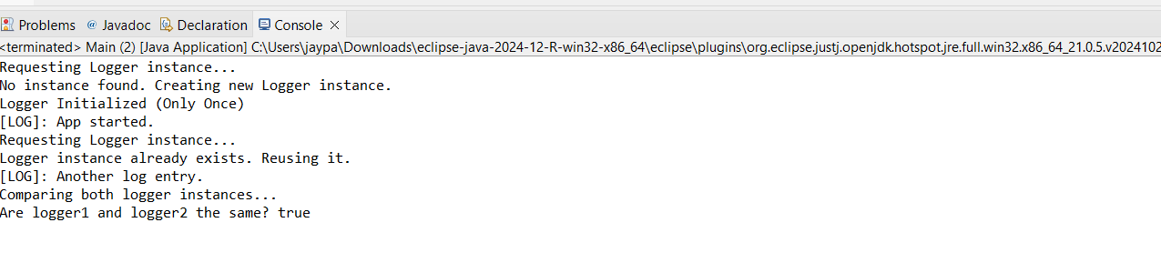

**Exercise 2: Implementing the Factory Method Pattern**

**Problem Statement:**

Developing a document management system that needs to create different types of documents (e.g., Word, PDF, Excel). Use the Factory Method Pattern to achieve this.

**Document.java  
package** com.factory;

**public** **interface** Document {

**void** open();

}

**DocumentTypes.java**

package com.factory;

class WordDocument implements Document {

@Override

public void open() {

System.*out*.println("Opening Word Document...");

}

}

class PdfDocument implements Document {

@Override

public void open() {

System.*out*.println("Opening PDF Document...");

}

}

class ExcelDocument implements Document {

@Override

public void open() {

System.*out*.println("Opening Excel Document...");

}

}

**DocumentFactory.java**

package com.factory;

public abstract class DocumentFactory {

public abstract Document createDocument();

}

class WordDocumentFactory extends DocumentFactory {

@Override

public Document createDocument() {

return new WordDocument();

}

}

class PdfDocumentFactory extends DocumentFactory {

@Override

public Document createDocument() {

return new PdfDocument();

}

}

class ExcelDocumentFactory extends DocumentFactory {

@Override

public Document createDocument() {

return new ExcelDocument();

}

}

**Main.java**

package com.factory;

public class Main {

public static void main(String[] args) {

DocumentFactory wordFactory = new WordDocumentFactory();

Document word = wordFactory.createDocument();

word.open();

DocumentFactory pdfFactory = new PdfDocumentFactory();

Document pdf = pdfFactory.createDocument();

pdf.open();

DocumentFactory excelFactory = new ExcelDocumentFactory();

Document excel = excelFactory.createDocument();

excel.open();

}

}

**OUTPUT**

